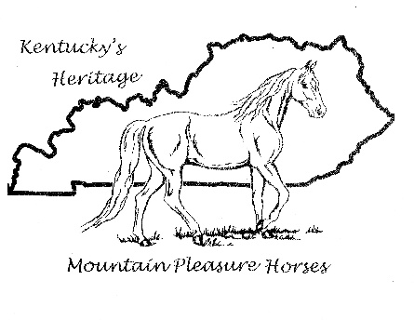
MPHA Horse Name Change Form*
*Note: Name can NOT be changed if animal has sired/produced offspring

- Horse Current Name:________________________________
- Horse RegistrationNumber:__________________________
- Current Owner of Horse:_____________________________
- Owner Address:_____________________________________
- Owner Phone Number: ______________________________
- Owner Email Address: _______________________________

- Requested (New) Horse Name:_______________________

I hereby certify that I am the current owner of above listed animal and further certify that said horse has not sired/bred or reproduced a Mountain Pleasure foal in the past. I agree if this is not the case, the horse’s new name will be forfeit.

__________________________________ _____________
Signed - owner Date:

